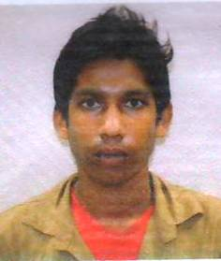
CURRICULUM VITAE
SOURAV MAJHI
Address: Vill-South Chandamari,
P.O.-Chandamari,
P.S-Kalyani,
Dist.- Nadia,
State- West Bengal, Pin- 741245
Mobile No: +91 8910694883
Email Address:souravmajhi682@gmail.com

CARRER OBJECTIVE:
To obtain a position that will allow me to utilize my technical skill experience and willingness to learn in making an organization successful.

PERSONAL INFORMATION

- Father’s Name : Guru Chand Majhi
- Date of Birth : 06/06/1997
- Sex : Male
- Marital Status : Single
- Nationality :Indian
- Religion : Hindu
- Cast : Sc
- Language known : Bengali, English, Hindi

PASSPORT DETAILS

PASSPORT NO :P0315189 PLACE OF ISSUE: KOLKATA
DATE OF ISSUE :11/07/2016 DATE OF EXPIRY :10/07/2026

EDUCATION QUALIFICATION
Name of Examination | Year of Passing | Board/University | Percentage /Grade
Madhyamik | 2015 | West Bengal Board Of Secondary Education | 32%

Declaration: I hereby declare that the above mentioned details are correct to the best of my knowledge.

Date:
Place: kalyani Signature

