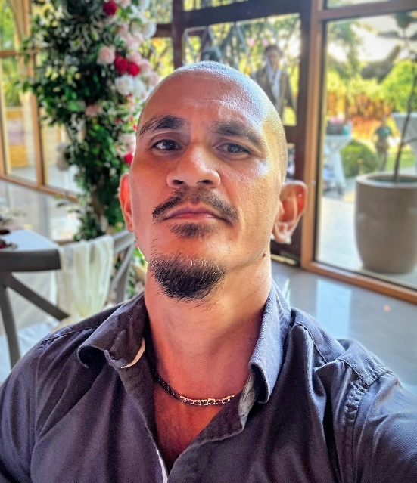  richard jumalon mariño  Blitzkreig120@yahoo.com/  mcc.rentals@yahoo.com  30B skynet street, moonwalk village, talon 5, las pinas city, philippines, 1747  mobile +63 9947296220 /+63 9228738872  Landline +63 0287721896  www.linkedin.com/in/richard-marino-3b3667118  https://www.jobstreet.com.ph/profile/richard-marino-FZtbGQP725  Objective  To enhance my analytical, problem-solving, management and coaching skills.  To obtain a position that will enable me to use my strong organizational skills, educational background, and ability to work well with people.  To be part of a company where I can use my experience in Customer Service can be utilized to improve customer satisfaction.  Role and People skills  Behavioral Coaching – In House Training in Both Hongkong Shanghai Bank Corporation (HSBC) and Capital One Bank USA. Specific in Handling Peers and New Hires to determine goals both long term and short term and creating an action plan on how to execute the process in a timely manner based on the coaching session.  Excellent Customer Experience Drive – A task Force that Spearheaded the drive for customer service enhancement for collections calls and recovery account. As one of the committee, task is to make sure easy and non-tension conversation thru positive verbiage and on the spot responses Taylor fit to the situation.  Sales Boot Camp – Part of the Team that promotes and shares sale techniques that are compliant and regulatory safe for American and UK standards to ensure the sale of an Upgrade or additional Services on the financial account.  Language Skills - I can Speak A1 Level German Language (Beginner Level)  Microsoft Skills with Excel, Word and Power Point.  Basic Canva usage of Advertisement Posters and online posting materials.  Experienced Online-social Media Postings and Promotions, via Facebook, TikTok, Instagram and Twitter and  Familiarization of On-Line payment methods using PayPal and Meta.  Professional Multi Level Marketer for  20 years, both On-line and Personal Approach in Direct selling.  CERTIFICATES  Culinary Arts Certificate Issued by Institute of Hotel and Restaurant Studies, under Chef Ulrich Williman and Hans Schallenberg  Hotel InterContinental Manila Certificate of Recommendation and Good Morale Character under Chef Bernie Abaya  University of Perpetual Help Rizal Recommendation Certificate from College of Hotel and Restaurant Management under Dean Narlyn Pineda |  | Work Experience  Civicom Pacific  Post: Senior Collections Account Manager Dec 2024-Present  Dept: POM Recoveries 3rd Party Debt Management New York  Loc: Unioil Center, Madrigal Business Park, Alabang, Muntinlupa City  Capital One Philippines Support Services Corp.  Post: Back Office Support/Senior Collections Associate Aug 2015 – Aug 2022  Dept: Collections Department / General Correspondence Back Office  Loc: Capital One ALA 2, Filinvest Two, Northgate Cyberzone, Filinvest City,  Alabang, Muntinlupa City  HSBC Electronic Data Processing Philippines Inc. Manila Site 2  Post: Senior Operations Rep/ October 2008 – August 2012  Dept: Marks and Spencer Money UK Account  Loc: Up-Ayala Techno Hub, University of the Philippines, 1101 Commonwealth Ave, Diliman, Quezon City, Metro Manila  HSBC Electronic Data Processing Philippines Inc. Manila Site 1  Post: Senior Operations Rep, Retention Specialist/ August 2005 – October 2008  Dept: US Cards Services Escalations  Loc: Filinvest One Building, Filinvest Ave, Alabang, Muntinlupa, Metro Manila  Hotel Intercontinental Manila  Post: Cold Kitchen Staff Intern 2000-2001Dep: Main Kitchen  Loc: Ayala Avenue, Makati City, Manila Philippines  Kamayan Restaurant Manila  Post: Main Kitchen Staff and Events Decoration Lead 1999-2000  Loc: Alabang Town Center, Alabang, Muntinlupa City, Philippines  Education and Certification  Institute of Hotel and Restaurant Studies (IHRS)  International Cuisine and Culinary Arts (2001-2003)  Culinary Arts Certification  Ortigas Center, Pasig City  Bachelor’s Degree in Hotel and Restaurant Management  University of Perpetual Help Dalta Las Piñas Campus (1997-2001)  Alabang–Zapote Road, Almanza Uno, Las Pinas, 1740 Metro Manila  Saint Francis of Assisi College  Admiral Village, Alabang–Zapote Road, Las Piñas, Manila Philippines  High School and Elementary  EXperience and training and awards  Experienced Nesting Coach – Facilitates Nesting Sessions for New Hires, such as Meet and Great, Systems, Familiarization of Tools, Briefing and De-Briefing Sessions, End of Day Report, and Progress report. Also assist in Up-Skilling of New Processes and Tools for New Hires and tenured Associates.  Team Point of Contact (POC) - In the event the Team Leader is out of office, I handle the team initial briefing session before and after the shift. Provides new updates on policies and procedures and creates end of day reports for the Operational Management Review.  Data Analyzing of Log-In Log-Out (LILO) Report – Checks for Patterns of Agents Off-Phone activities, duration, reason and possible report of violations.  Strong Customer Service Skills – in the 16 years of experience working with various type of customers, skills in handling customers thru empathy and positive responses and accurate handling of difficult customers has been mastered.  Good Time Management Skills – Multi-Tasking is a talent to do simultaneous tasks at the same time, making sure that the work is done effectively and efficiently in a timely manner.  Creative Problem-Solving Skills – thinking of ways how to deal with situations both customer based and peers in the office. Offering positive responses to achieve maximum benefit and results. (Work Plans, Daily Tasks, and assessing in a Simple, Measurable, Accurate, Realistic and Time Bound solutions.  Has strong people skills – I can easily communicate and relay thoughts in a positive tone to my peers and clients in a manner that it is easy to understand. No jargons for better understanding. Easily approachable.  Net Promoter Elite– Recognition in achieving the Survey Results from American and UK customers stating satisfaction on the service that they received regarding their concern and an extra mile.  Net Promoter Score (NPS) Champion - Consistently Achieving High Scores on Surveys both internal and external factors in a Financial Institution.  High Sales Ranker – Achieving High Sales Record Consistently in Cross selling other services offered by the Financial Institution such as Account Secure Programs, Identity Theft, Credit Watch and Auto Loans.  Cold Kitchen Staff – Main task is preparation of the daily food items used in the main kitchen and cold kitchen. Additional Task, food arrangement and buffet setup for events and basic table arrangement. Academic Awards in Table Setting and Theme Design for Parties and Events.  Reference  Michelle Renes  Unit Manager, Capital One  Mobile: +63 09175574806  Employee ID: 463153  Rommel Mistica  I-Fern Distributor Team Builder  Mobile: +63 9258000025

